Name: _KEY____________________________ Period: __________ Date: ______________
Biology Test 1 Study Guide
Characteristics of Living Things, Viruses, Classification of Living Things
I. Review Concepts
A. Lab Safety: For each of the lab safety scenarios below, highlight what the student did wrong, and write what the student should have done in the spaces below.
1. The teacher was not in the room yet. Jake began weighing chemicals, touching them with his hands. His nose itched, so he rubbed it. Don’t touch anything until the teacher tells you to. If you get chemical on your hands, wash them first.
2. Cindy broke a test tube. Carefully, she picked up the pieces with one hand and placed them in the other hand. Then she dumped the glass pieces into the trash can. If you break glass, don’t touch it. The teacher will put it in the broken glass container.
3. The cuff of Sam’s long sleeved shirt caught fire. He ran to show his teacher. Wear short sleeve shirts. If your clothing catches fire, don’t run, either stop, drop and roll or use a fire blanket to smother the flames.
B. Scientific Method: Read the scientific scenario below and answer the questions that follow.
Maggie read that some plants grow better if the soil is acidic. She can’t believe that a plant can grow when exposed to acid. Maggie decides to test if the plants she has will grow better when acid is added to the soil. She puts potting soil in two planting containers and transplants two of her geraniums that seem about the same size into the pots. She puts the pots in the same location so that they both get the same sunlight each day, are at the same temperature and she makes sure they get the same amount of water. However, Maggie puts a tablespoon of vinegar in the water she gives to one of the plants. She measures the growth of the plants every week for five weeks and records the results in a data table below:
Week | Height of plants in container WITH vinegar  (cm) | Height of plants in container WITHOUT vinegar (cm)
1 | 10.0 | 10.0
2 | 12.4 | 11.5
3 | 14.8 | 13.0
4 | 18.0 | 15.7
5 | 21.4 | 17.8

1. Hypothesis: _If I add vinegar to my plant’s water supply, the plants will grow taller._
2. Independent Variable: _type of water given (either vinegar water or plain water__
3. Dependent Variable: _the height of the plants__
4. Experimental Group: __the group of plants that received vinegar water___
5. Control Group: __the group of plants that received the plain water____
6. Constants: __sunlight, amount of water, temperature__
II. Characteristics of Living Things
A. Characteristics of Living Things: List the eight characteristics of living things in the spaces below.
1. Composed of cells 3. Obtain materials and use energy 5. Contain a universal genetic code 8. Grow/
2. Reproduction 4. Evolve/Adapt 6. Maintain homeostasis 7. Respond to stimuli Develop
B. Vocabulary Matching: Match the vocabulary word with its correct definition.
__F__ 1. Unicellular a. A cell that does not contain a nucleus or membrane-bound organelles
__K__ 2. Multicellular b. The genetic code for all living things
__A__ 3. Prokaryote c. Two organisms combining DNA to produce a genetically different offspring
__H__ 4. Eukaryote d. A change in an organism in response to its environment
__C__ 5. Sexual Reproduction e. Carbohydrates, Proteins, Lipids, Nucleic Acids found in all living things.
__N__ 6. Asexual Reproduction f. Composed of only one cell
__D__ 7. Adapt g. Getting bigger by adding more cells
__J__ 8. Metabolism h. A cell that does contain a nucleus and membrane-bound organelles
__B__ 9. DNA i. The ability to keep a constant internal environment
__E__ 10. Macromolecules j. Taking in food and using it for energy
__I__ 11. Homeostasis k. Composed of many cells
__L__ 12. Stimulus l. Something that produces a response in an organism
__G__ 13. Grow m. Changing from one form to another
__M__ 14. Develop n. One organism producing an offspring that is genetically identical
C. Applying Concepts: For each of the statements below, write the characteristic of living things that BEST applies.
1. A bear eats a great amount of food in the summer and fall to prepare for hibernation in the winter.
Metabolism—taking in food and utilizing energy
2. Bacteria are the only prokaryotic organisms. All organisms are composed of one or more cells.
3. My neighbor is having twins. Reproduction
4. A butterfly starts as an egg, then enters the larval stage (caterpillar), then pupates, then becomes an adult.
Development
5. The fur of arctic polar bears has become thinner over the years due to slightly warmer temperatures in the arctic.
Adapting to the environment through natural selection
6. A protist, known as Euglena sp., is photosynthetic and thus will swim toward light. Response to stimuli
7. I begin sweating when I go out to exercise in the 104 degree heat. Maintaining homeostasis
8. A crime scene is investigated by using gel electrophoresis, a technique that compares the DNA of the victim to the DNA of potential suspects. All organisms are based on a universal genetic code, which is DNA.

*** IS motility a characteristic of living things? No organisms do not have to be motile to be alive.
*** Something must possess all 8 characteristics in order to be considered living. (True or False)
III. Viruses
A. Vocabulary: Match the vocabulary term with its proper definition.
__E__ 1. Capsid a. A virus that infects a bacterium
__F__ 2. Viral Nucleic Acid b. Viral cycle that involves the virus inserting its DNA into the host DNA
__G__ 3. Provirus c. The only way to prevent against a virus (antibiotics don’t help!)
__A__ 4. Bacteriophage d. A living cell that is taken over by a virus and used to replicate new viruses
__D_ 5. Host cell e. Outer protein coat of a virus
__C__ 6. Vaccine f. Either DNA or RNA but never both
__H__ 7. Lytic g. Viral DNA that is inserted into host cell DNA
__B__ 8. Lysogenic h. Viral cycle that involves disabling host DNA and then using the host cell to lyse new viruses
B. Labeling: Label each of the diagrams below.
1. Label the virus below using the following words: 2. Label the 5 stages of lytic cycle below and tell what
sheath, tail fibers, capsid, DNA. is happening in each stage.
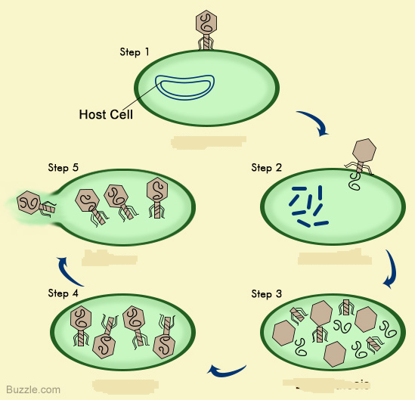
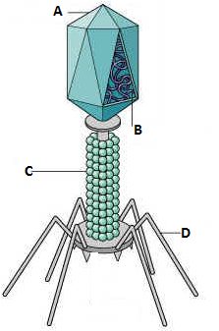
A. CAPSID

B. DNA OR RNA

C. SHEATH

D. TAIL FIBERS

Step 1: Attachment- virus attaches to the host cell.
Step 2: Entry- virus injects DNA into host cell.
Step 3: Replication- viral DNA commands host to make more virus parts.
Step 4: Assembly- virus parts are put together
Step 5: Lysis- Host cell bursts open releasing new viruses.

3. Tell how the lysogenic cycle is different from the lytic cycle above, and tell how it is similar.
Differences Provirus formation and Cell Division Similarities Attachment, Entry, Replication, Assembly and Lysis
III. Classification
A. Vocabulary: Match the vocabulary word with its proper definition.
__H__ 1. Taxonomy a. The smallest taxon
__C__ 2. Taxon b. The first person to develop a classification system based on color and movement
__E__ 3. Binomial Nomenclature c. A group or level of organization in taxonomy; a taxonomic category
__J__ 4. Kingdom d. Father of modern taxonomy
__A__ 5. Species e. A system of naming organisms with two names, a genus and a species
__B__ 6. Aristotle f. The study of comparing organisms based on a common ancestor
__D__ 7. Linnaeus g. Comparing the DNA and RNA sequences of different organisms
__F__ 8. Phylogeny h. The science of classifying organisms
__I__ 9. Comparative Embryology i. Comparing the embryo stages of different organisms
__G__ 10. Comparative Biochemistry j. The largest taxonomic category, other than the domain
B. Applications: Answer the following questions or fill out the appropriate information.
1. List the 7 taxa from largest to smallest, beginning after domain.
Domain, Kingdom, Phylum, Class, Order, Family, Genus, Species
2. When naming an organism using binomial nomenclature, which two levels of taxa are given to an organism? Genus and species
3. How are they written? Which one is capitalized? Genus is capitalized, species is lowercase, either underlined or italics
4. Using the scientific name of a human, Homo sapiens, which one is the genus? Which is the species? Homo is the genus and sapiens is the species
5. Use the chart below to answer the questions.
a. Which organism is least related to the others? almond
b. Which two organisms are most closely related? Peanut and green bean
c. Why? They share more taxa
d. At which level do all three organisms differ? Genus level

TAXA | ALMOND | PEANUT | GREEN BEAN
Kingdom | Plantae | Plantae | Plantae
Phylum | Angiosperms | Angiosperms | Angiosperms
Class | Rosids | Rosids | Rosids
Order | Rosales | Fabales | Fabales
Family | Rosaceae | Fabaceae | Fabaceae
Genus | Prunus | Arachis | Phaseolus
Species | dulcis | hypogaea | vulgaris

6. Use the cladogram below to answer the questions.
a. Name the organisms that have eggs with shells.
Birds and crocodiles
b. Name the organisms that have hair. Primates, rabbits and rodents
c. Name the organism that does not have a bony skeleton. sharks
d. Name the organisms that do not have four limbs. Fish & sharks
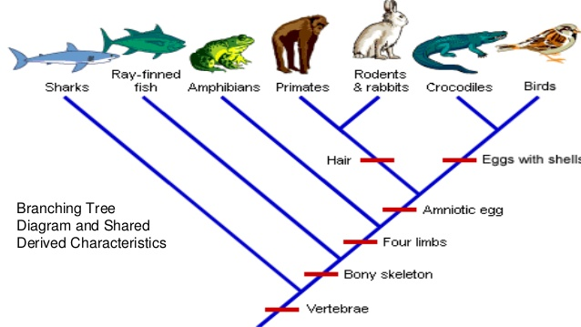

7. Identify the insect order below using the dichotomous key below. Order Coleoptera
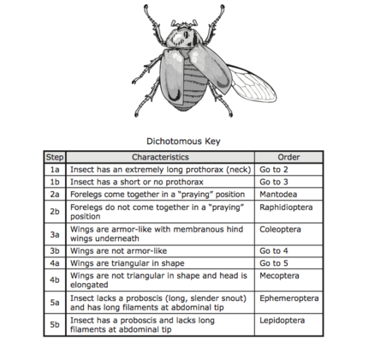
8. What are the 3 domains and which kingdoms do they include? Domain Archaea contains only Kingdom Archaebacteria, Domain Bacteria contains only Kingdom Eubacteria, Domain Eukarya contains Kingdoms Protista, Fungi, Plantae and Animalia.
9. Fill out the table below on the 6 kingdoms and answer the questions that follow.
KINGDOM | PROKARYOTE OR EUKARYOTE? | CELL WALL? SUBSTANCE? | UNICELLULAR OR MULTICELLULAR? | AUTOTROPH OR HETEROTROPH?
K. ARCHAEBACTERIA  Domain Archaea | Pro | Yes but without Peptidoglycan | Uni | Both
K. EUBACTERIA  Domain Bacteria | Pro | Yes with  Peptiglycan | Uni | Both
K. PROTISTA  Domain Eukarya | Eu | Yes, cellulose | Mostly Uni  Algae is Multi | Both
K. FUNGI  Domain Eukarya | Eu | Yes, chitin | Multi | Hetero  Decomposers
K. PLANTAE  Domain Eukarya | Eu | Yes, cellulose | Multi | Auto
K. ANIMALIA  Domain Eukarya | Eu | NO | Multi | Hetero

- Which kingdom is composed of unicellular prokaryotes with cell walls composed of peptidoglycan? Eubacteria
- Which kingdom is contains unicellular eukaryotes that may be autotrophic or heterotrophic? Protista
- Which kingdom is completely multicellular and autotrophic? _Plantae_____
- Which kingdom is completely multicellular and heterotrophic? _Animals___
- Which kingdom has no cell walls? _Animalia______
- Which kingdom contains organisms such as halophiles, acidophiles and methanogens? _Archaebacteria__
- Which kingdom contains multicellular organisms with cell walls of cellulose? _Plantae__

